Deerwalk Institute of Technology
Sifal, Kathmandu

Artificial Intelligence Practical - 6

Submitted By: Submitted To:
Name: Sagar Giri Sudan Prajapati
Roll No: 205
Section: A

Date: 22 April 2015
Negation as failure:
Example1:

enjoys(vincent,X) :- big_kahuna_burger(X),!,fail.
enjoys(vincent,X) :- burger(X).
burger(X) :- big_mac(X).
burger(X) :- big_kahuna_burger(X).
burger(X) :- whopper(X).
big_mac(a).
big_kahuna_burger(b).
big_mac(c).
whopper(d).

Output:
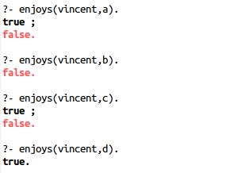

Task1
Mary Likes all animal but snakes. How can we say this in prolog ? It is easy to express one part of this statement .Mary likes any X If X is an animal. But we have to exclude snakes. IF X is a snake then ‘Mary likes X’ is not true. Otherwise if x is an animal then Mary like X. Make a goal and facts to illustrate above example.
Program Coding:
likes(marry,X):-animals(X),!.
likes(marry,X):-snakes(X),!,fail.

snakes(cobra).
snakes(harara).
snakes(python).

animals(cat).
animals(dog).
animals(snakes).
animals(elephant).

Output:
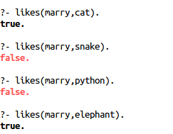

Inequality in prolog

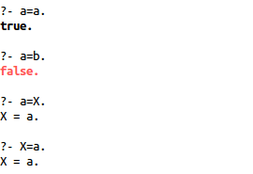
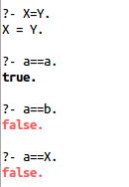
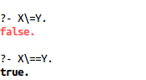
Negation in Prolog:

Fact:
university(uoft).

Output:

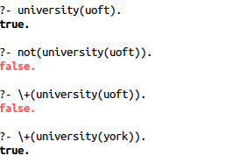

Negation Implementation:

sad(X) :- \+ happy(X).
happy(X) :- beautiful(X), rich(X).

rich(bill).
beautiful(michael).
rich(michael).
beautiful(cinderella).

Output:
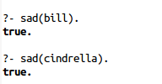

Task2:
facts:
color(red). color(orange).color(yellow).
color(green).color( blue).
color(purple).color(black).
color(brown).color(gold).
muddcolor(black).
muddcolor(gold).
awesomescolor(X,Y):-muddcolor(X),muddcolor(Y), X\==Y.
checkInequlaityEarly(X,Y):-X\==Y,muddcolor(X),muddcolor(Y).
notmuddcolorbroken(X):- not(muddcolor(X)).
notmuddcolor(X):-color(X),not(muddcolor(X)).

Output:
